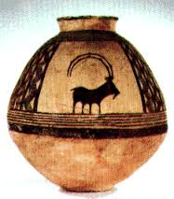
Early Civilizations
- Name five tools or techniques used to increase crop production:
  - _____________________________
  - _____________________________
  - _____________________________
  - _____________________________
  - _____________________________
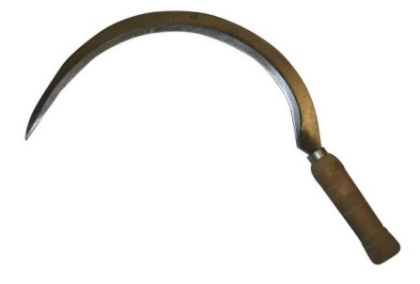
- What is this tool called and what does it do?

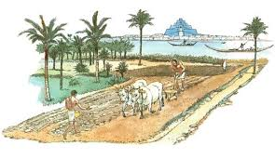

- What is a food surplus?

- What is the benefit of having a food surplus?

- What does each of these people do?

  - Merchant _____________________________
  - Artisan _____________________________
  - Priest _____________________________
  - Government official _____________________________
- Fill in three types of professions in each class of the social structure.
UPPER CLASS | MIDDLE CLASS | LOWER CLASS
- Fill out the costs and benefits of settled living.
Benefits of the settled life | Costs of the settled life
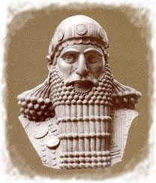
- List three responsibilities of government in early civilizations.
  - ___________________________
  - ___________________________
  - ___________________________
- What kind of power did priests claim to have?

